This, of course, is not required, just a fun way to keep you thinking about and working on your photography skills. Have a great summer! - Ms. Jensen

Stairways
Stairways are fascinating. They lead somewhere—somewhere above our everyday world, or somewhere below it. They also make great photo subjects. Take your camera out, find some stairways, and see what you can do with them photographically. Move close, move back, shoot from the bottom looking up and from the top looking down, experiment with framing, and maybe include a person (or several).
Stairways can lead you to interesting photos. Keep your eyes open for photographic possibilities, and for the steps—you don't want shots taken while falling down the stairs!
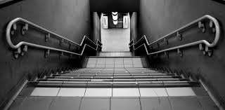
Frames
This assignment is simple: You can add interest to photos of many subjects by framing them with a handy foreground object. A key here is depth of field—you generally want both the frame and the subject to be sharp.
If you look for them, you can find lots of things to use as frames for your photo subjects.
