ENERGY WEBQUEST
Assessment

1. "Energy cannot be created nor destroyed in any chemical reaction. It can only be changed from one form to another." This is known as the Law of:
A. Energy Transformation
B. Conservation of Energy
C. Energy Transfer

2. During energy transformation, energy is never ____________.
A. used to increase an object's potential energy
B. released as heat
C. created or destroyed

3. As energy transformations occur within a system, the total energy of the system _________.
A. remains constant
B. decreases
C. increases

4. Which of the following objects has kinetic energy?
A. a ball rolling across the floor
B. leaves lying on the ground beneath a tree
C. a bicycle parked at the top of a hill

5. ______________ is the energy stored in an object due to its position.
A. Kinetic energy
B. Thermal energy
C. Potential energy

- The diagram below shows a roller coaster. Use this diagram to answer the next question.
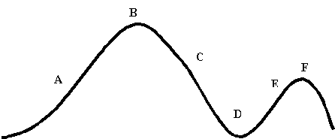
(From: http://galileo.phys.virginia.edu/education/
outreach/8thgradesol/EnergyPendulum.htm)
At what point in the journey of the roller coaster is potential energy transforming into kinetic energy?
- Point A
- Point B
- Point C
- Point D

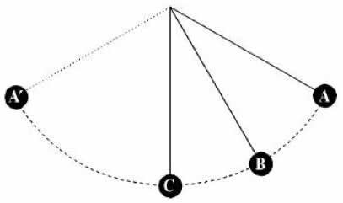
(From: http://albertgrasmarti.org/agm/recerca-divulgacio/pendulum-TPT.pdf)
In the figure above
  - position A is the point of maximum potential energy and minimum kinetic energy.
  - position B is the point of maximum potential energy and minimum kinetic energy.
  - position A is the point of maximum kinetic energy and minimum potential energy.
  - position B is the point of maximum kinetic energy and minimum potential energy.

- Below is a figure of a pendulum. The letters represents specific points that the pendulum passes through in its swing. Use this figure to answer the next question.
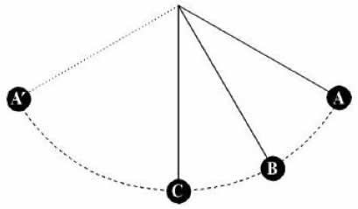
(From: http://albertgrasmarti.org/agm/recerca-divulgacio/pendulum-TPT.pdf)
In the figure above, the letter representing the point where kinetic energy and potential energy are equal is
- Point A
- Point B
- Point C
- Point A'

